GSLC – Session 5 (LD01)

# To Do

**Accessing Learning Materials Session 5 (newbinusmaya).**

# Personal Assignment

## **Essay**

1. What is **Blade Templating Engine**? Explain in detail.
2. What if the files in **Views** don't use **.blade.php**?
3. In Session 3, you have successfully completed an “About Page” using routes. Now, change the code by using the Blade Templating Engine. Show the code and the result.

## **Case (Use Blade Templating Engine)**

Create a web page with a **Navbar** that contains:

* Home
* About, and
* Blog

So, we can click on the Home, About, and Blog pages.

The content of Home, About, and Blog pages can be change according to the creativity of each student. You can also change the color, font, etc.

**Example:**

**Home page:**

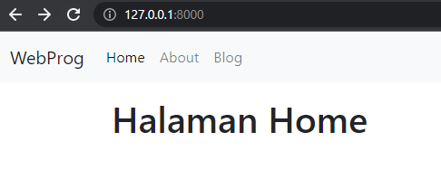

**About page:**

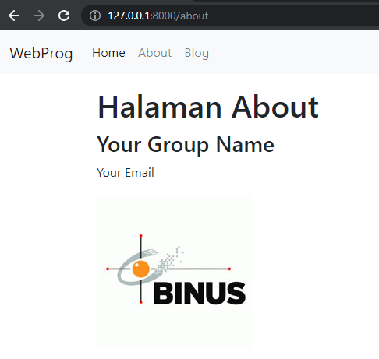

**Blog page:**

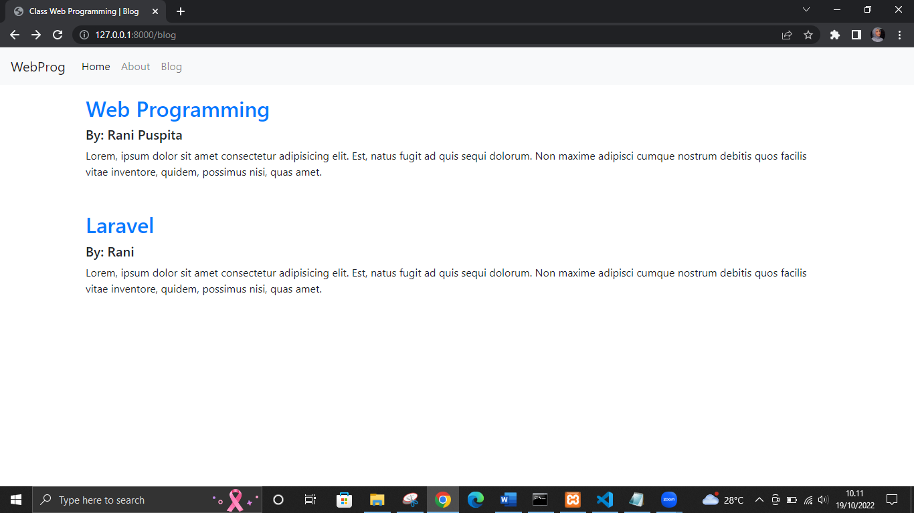

# Documentation

* Answer the essay questions and create documentation by showing the tutorials in **.docx** or **.pdf** format.

# Send

Newbinusmaya – Forum Reply – Session 5

# Deadline

**Sat, Oct 30, 2022 – 23:59**